Electronic Components
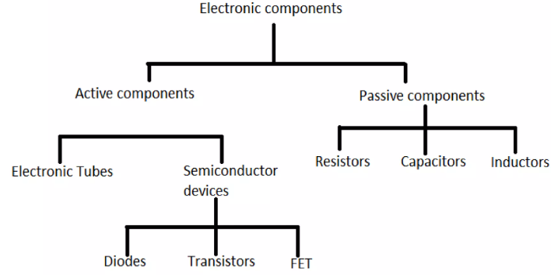
Electronic components are the elements of an electronic circuit. They work together to create modern electrical systems. Computers are made of electronic components referred to collectively as hardware.

Passive Components characteristics:
- Do not require an external power source to operate.
- Cannot amplify signals or provide power gain.
- They consume, store, or dissipate energy (as heat, electric field, or magnetic field).
- Typically, bidirectional (current can flow in both directions, except for some like polarized capacitors).
.
Active Components characteristics
- Require an external power source to operate.
- Can amplify, control, switch, or generate signals (provide power gain or inject energy into the circuit).
- Control the flow of current or voltage.
- Usually unidirectional or depend on control signals.
Active Components examples
- Diode — Allows current in one direction (rectification); LEDs, Zener diodes often classified here.
- Transistor (BJT, MOSFET, JFET) — Amplifies or switches signals; core of modern electronics.
- Integrated Circuits (ICs) — Op-amps, microcontrollers, logic gates, timers (contain many transistors).
- SCR / Thyristor, TRIAC — Controlled switching.
- Voltage / Current sources (ideal models), Oscillators.
NB:
Some diodes (e.g., ordinary rectifier diodes) are sometimes grouped as passive, but most modern classifications place diodes under active components because they control current direction and involve non-linear behaviour. LEDs are active components (they emit light using supplied energy)

Common Examples of passive components (80% of the electronic components)
- Resistor (R) — Opposes current flow (dissipates energy as heat); Ohm's Law V = IR.
- Capacitor (C) — Stores energy in electric field; blocks DC, passes AC; I = C dV/dt.
- Inductor (L) — Stores energy in magnetic field; opposes change in current; V = L dI/dt.
- Transformer — Transfers energy magnetically (no power gain).
- Others: Fuses, switches (mechanical), some antennas.

Capacitors
Capacitor is a device that stores electrical energy in an electric field. It is also called a Condensor or Condensator. • Most capacitors contain at least two electrical conductors often in the form of metallic plates or surfaces separated by a dielectric medium. • The conductor may be a foil, thin film, or an electrolyte. • Dielectric Materials commonly used are glass, ceramic, plastic film, paper, mica, air, and oxide layers.
• Capacitors are simple passive devices that can store electrical charge on their plates when connected to a voltage source, Q = C x V Coulombs. • When used in a direct current or DC circuit, a capacitor charges up to its supply voltage but blocks the flow of current through it because the dielectric of a capacitor is non-conductive and basically an insulator. • When it is connected to an alternating current or AC circuit, the flow of the current appears to pass straight through the capacitor with little or no resistance.
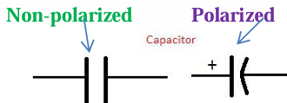
• The generalised equation for the capacitance of a parallel plate capacitor is given as: C = ε (A / d) where ε represents the permittivity of the dielectric material A is the cross-sectional area of the parallel plates d is the distance between the parallel plates. • The effect of capacitor is called the capacitance and is measured in Farad.
Applications of Capacitors • Power Supply Smoothing • Audio Frequency Coupling • RF Coupling Capacitor Applications • RF Decoupling Applications • Tuned Circuits.

Inductor
Inductor (also called a coil, choke, or reactor) is a passive two-terminal electrical component that stores energy in a magnetic field when electric current flows through it. An inductor typically consists of an insulated wire wound into a coil around a core. It works on Faraday’s law of Electromagnetic induction. • An electric current flowing through a conductor generates a magnetic field surrounding it. • The magnetic flux linkage generated by a given current depends on the geometric shape of the circuit. Their ratio defines the inductance L. • Many inductors have a magnetic core made of iron or ferrite inside the coil, which serves to increase the magnetic field and thus the inductance. • Inductor is characterized by its inductance, which is the ratio of the voltage to the rate of change of current. The unit of inductance is the Henry (H), equivalent to weber/ampere.
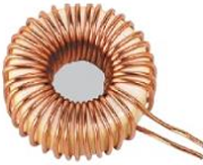
• They are used to block AC while allowing DC to pass. They are also used in electronic filters to separate signals of different frequencies, and in combination with capacitors to make tuned circuits, used to tune radio and TV receivers. • Two (or more) inductors in proximity that have coupled magnetic flux (mutual inductance) form a transformer, which is a fundamental component of every electric utility power grid.

Applications of inductor:
Used extensively in analogue circuits and signal processing. For example, removes ripple in power supplies. ↔ Small inductance of the ferrite rod installed around a cable to prevent radio frequency interference. ↔ Used as the energy storage device in many switched-mode power supplies to produce DC current. ↔ A tuned circuit (L and C) acts as a resonator in radio transmitters and receivers, as narrow bandpass filters to select a single frequency from a composite signal, and in electronic oscillators to generate sinusoidal signals. ↔ Two (or more) inductors are used in the construction of a transformer (basic in electric utility power grid).

Resistor Colour Coding (Most Important & Standard for Passive Components)
Resistor Colour Coding (Most Common)
Resistors almost always use the IEC 60062 / EIA standard colour code. Read bands from left to right (tolerance band is usually separated by a wider gap or is gold/silver).
- 4-band (most common): Digit 1 – Digit 2 – Multiplier – Tolerance
- 5-band (precision): Digit 1 – Digit 2 – Digit 3 – Multiplier – Tolerance
- 6-band (rare, adds temp. coefficient): + one more band for TCR (ppm/°C)
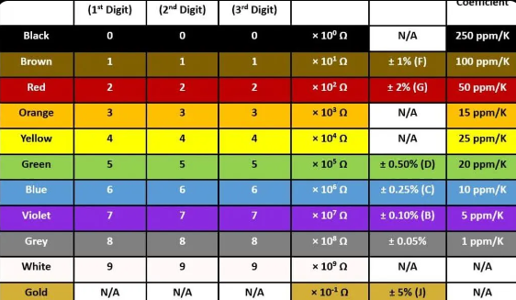

Resistors use coloured bands to determine the value, tolerance, and (in precision types) temperature coefficient. Reading starts from the end closest to the band (or the wider gap side).
Examples
- Brown–Black–Red–Gold → 10 × 100 = 1 kΩ ±5%
- Red–Violet–Orange–Gold → 27 × 1k = 27 kΩ ±5%
- Yellow–Violet–Green–Silver → 47 × 100k = 4.7 MΩ ±10%
- 5-band: Brown–Red–Black–Brown–Brown → 120 × 10 = 1.2 kΩ ±1%

Capacitor Colour Coding (Older Ceramic Disc / Tubular Types)
- Modern capacitors mostly use printed numbers (e.g., “104” = 100 nF), but older disc/tubular types use colour bands similar to resistors. Value is in picofarads (pF).
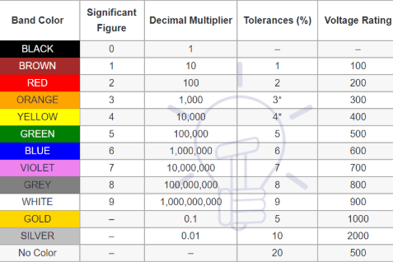

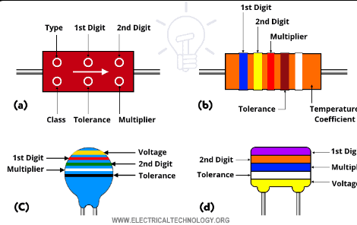

Same colour meanings as in resistors (but value = pF).
- Bands 1–2 (or 1–3) = significant digits
- Next = multiplier
- Next = tolerance
- Sometimes last = voltage rating or temperature
- Example: Brown–Black–Orange = 10 × 1,000 = 10,000 pF = 10 nF Gold/Silver = tolerance (±5%/±10%)
Inductor Colour Coding (Colour-Ring / Axial Types)
Less common today (most are printed or SMD), but color-ring inductors follow almost the same system as resistors — value in microhenries (μH).
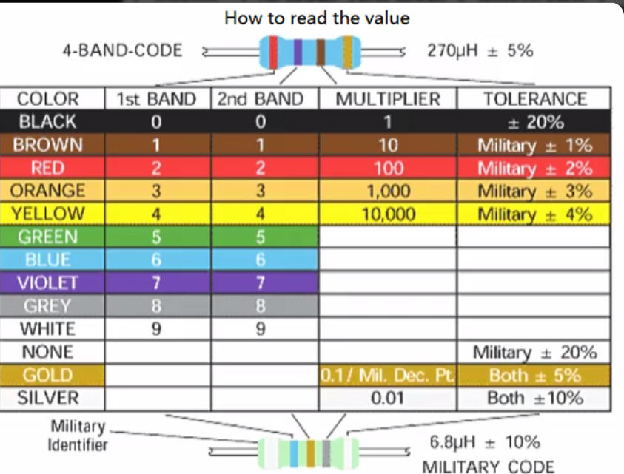
Example: Red–Violet–Gold = 27 × 0.1 = 2.7 μH Tolerance often ±10% (Silver) or ±5% (Gold).
NB
- Always read from the correct end (tolerance band is usually gold/silver or widest gap).
- SMD components (tiny chips) use numeric codes instead of colours: – Resistor: 103 = 10 × 10³ = 10 kΩ – Capacitor: 104 = 10 × 10⁴ pF = 100 nF
- Colour coding is mainly taught for through-hole parts in basic electronics.

